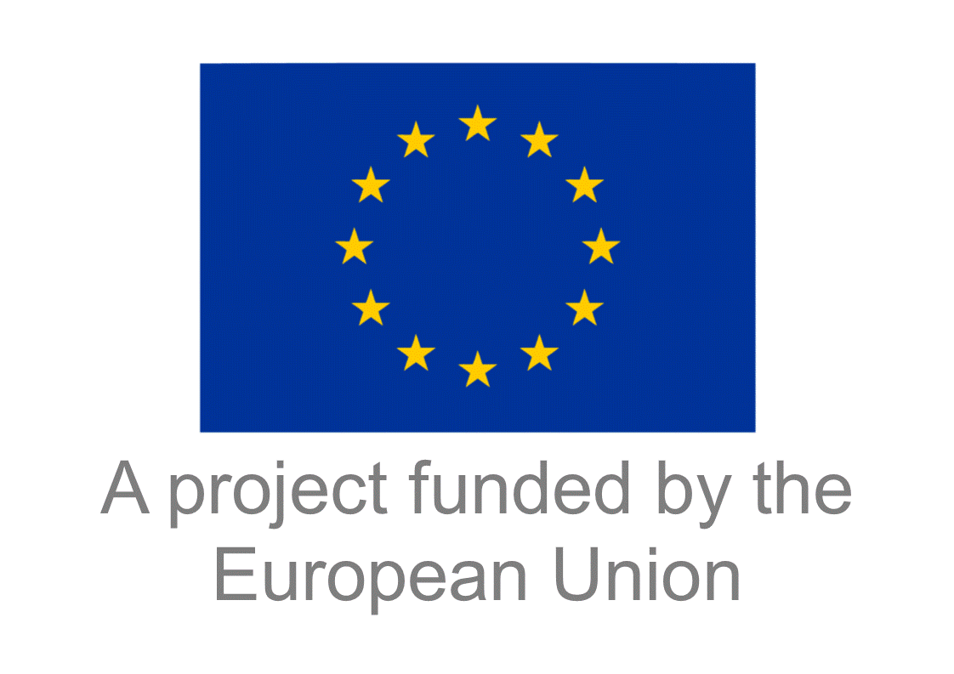

REQUEST FOR EXPRESSION OF INTEREST

# **EAC QUALITY CHAMPIONS**

Are you passionate about quality? Want to make a difference? Want to be part of a national team of quality champions to support the business community on a long term basis? If so, this is for you and we encourage you to apply.

You will be trained and guided by high level international experts with the opportunity of obtaining an international certification in quality management *(Basic Quality Professional Diploma and Advanced Quality Professional Diploma)* awarded by ITC and the World Alliance for Quality.

As part of your training, we expect you be involved in outreach and awareness initiatives related to quality and also to directly assist enterprises, including exporters, processors and other actors in the value chain in the agro-foods sector over a 7-9 month period to implement quality enhancement initiatives. Once qualified, you are expected to function as master trainers (i.e train other trainers), lead quality related initiatives and to serve as part-time expert trainers and advisors at national and regional level via one or more service providers. A total of 20 Quality Champions will be selected in Burundi, Kenya, Rwanda, Tanzania and Uganda.

The programme will include the following short courses &components:

1. *Quality 101: Introduction to Quality*
2. *Quality 102: Standardizing Work*
3. *Quality 103: Quality Assurance*
4. *Quality 104: Quality Control*
5. *Quality 105: Quality Improvement*
6. *Quality 106: Quality Planning*
7. *Quality 107: Quality Management*
8. *Quality 108: Managing for Quality*
9. *Quality 109: Service Quality and Customer Relationship Management*
10. *Quality 110: Quality Management System Design*
11. *Quality 111: Basic Problem Solving for Quality Improvement*
12. *Quality 112: Personal Quality and Career Development*
13. *Structured Problem Solving – Lean Six Sigma Green Belt*
14. *Food Safety*
15. *Transfer, adaptation and development of local courses*
16. *Training techniques, assessment &advisory skills, team building, meeting management, mentoring/coaching and other soft skills*
17. *Implementation of quality& food safety enhancement project in an exporting company, processor or producer group*

We welcome individuals with a focus and passion for quality to apply. We see the teams in each country to consist of a mix of senior experts as well as younger professionals, both of whom may have a mix of skills sets related to quality management, food safety, process improvement and/or specific sector expertise.

**Applicants must meet the following criteria to qualify for selection**

* Minimum of 5 years of professional experience in quality management, production management, agro-processing, exports of agricultural products, food safety or other relevant areas.
* Experts with less than 5 years’ experience should have at least a Bachelor’s degree in relevant field (e.g Science, Agriculture, Business Management, Engineering, Food science, Food technology, Quality Management or equivalent)
* Availability to dedicate an average of 4 days per month over period of 1 year, out of which approximately 50% will be during working hours
* Commitment to be part of a network of trainers and advisors to help others grow and develop by serving as expert trainers and advisors as well a master trainers on a long term basis via national service providers.

This training will take place in the context of the EU funded Market Access Upgrade Project (MARKUP), which aims to support increased exports of agribusiness and horticultural products from the EAC region with a particular focus on the EU market. The main sector focus by country will be as follows:

Burundi: Coffee, Tea

Kenya: Avocado, Tea Coffee

Rwanda: Coffee, Horticulture

Tanzania: Avocado, Tea, Coffee, Spices

Uganda: Coffee, Cocoa

*All training will be free of charge. Transport and accommodation will be covered for regional events only. In the case of national events, a contribution to local transport and/or accommodation costs may be given in selected cases if long distance travel is involved but otherwise no financial compensation will be given during the training period.*

**APPLICATION FORM**

***To be sent by mail to the address below no later than 31 January 2019:***

*Ms Margareta Funder von Kirchbach, Officer, Export Quality Management, International Trade Centre Geneva Switzerland*

*Mail: funder@intracen.org*

**NB: Shortlisted candidates will be called for an interview as part of the selection process**

**General**

|  |  |
| --- | --- |
| **Full Name** |  |
| **Date of Birth:** |  |
| **Citizenship** |  |
| **Country of Residence** |  |
| **Sub county of Residence/District** |  |

**Contact details**

|  |  |
| --- | --- |
| **Physical address** |  |
| **Town** |  |
| **Country** |  |
| **Mobile telnumber** |  |
| **Email address** |  |
| **Skype address if available** |  |

**Education:**

|  |  |  |
| --- | --- | --- |
| **Institutions:** | **Degree(s) or Diploma(s) obtained:** | **Specialization** |
|  |  |  |
|  |  |  |
|  |  |  |

**Professional trainings undertaken if any**

|  |  |  |  |
| --- | --- | --- | --- |
| **Course title** | **Duration** | **dates** | **Name of institution** |
|  |  |  |  |
|  |  |  |  |
|  |  |  |  |

**Employment record and experiencestarting with the current**

|  |  |  |  |
| --- | --- | --- | --- |
| **Period** | **Employing organization and your title/position. Contact info for references** | **Position** | **Summary of activities performed/ responsibilities** |
|  |  |  |  |
|  |  |  |  |
|  |  |  |  |
|  |  |  |  |
|  |  |  |  |
|  |  |  |  |
|  |  |  |  |

**Membership in Professional Associations if any**

|  |  |
| --- | --- |
| Professional body | Reference Number if applicable |
|  |  |
|  |  |
|  |  |

**Language Skills (5 – excellent, 1 – poor)**

|  |  |  |  |
| --- | --- | --- | --- |
| **Language** | **Reading** | **Writing** | **Speaking** |
|  |  |  |  |
|  |  |  |  |
|  |  |  |  |
|  |  |  |  |

**Use the space below to outline your key areas of expertise in relation to the programme**

|  |
| --- |
|  |
|  |
|  |
|  |
|  |
|  |

**Please indicate any previous experience you may have had as a trainer or advisor**

|  |
| --- |
|  |
|  |
|  |
|  |
|  |

**In case you are currently involved with any service provider other than your current employer (eg by delivering part time/evening time training and/or advisory services), please describe your role and the type of initiatives you are involved in**

|  |
| --- |
|  |
|  |
|  |
|  |
|  |

**Please describe any specific quality related initiatives that you are/have been directly involved in**

|  |
| --- |
|  |
|  |
|  |
|  |
|  |

**Please describe your main reasons for wanting to join this program**

|  |
| --- |
|  |
|  |
|  |
|  |
|  |
|  |

**Please elaborate on your commitment to serve as a trainer/advisor on a long term basis through national service providers upon qualification, including how much time would have available, any particular constraints, etc.**

|  |
| --- |
|  |
|  |
|  |
|  |
|  |

I, the undersigned, certify that to the best of my knowledge and belief, the above information correctly describes myself, my qualifications, and my experience, and I confirm my availability to participate fully in the trainings and enterprise support activities. I understand that any misstatement or misrepresentation described herein may lead to my disqualification .

|  |  |  |
| --- | --- | --- |
| Name of Applicant | Signature | Date |