RWANDA STANDARD | DRS  512  First edition  2022-mm-dd
Clay roofing tiles and ridges — Specification

In order to match with technological development and to keep continuous progress in industries, standards are subject to periodic review. Users shall ascertain that they are in possession of the latest edition
© RSB 2022
All rights reserved. Unless otherwise specified, no part of this publication may be reproduced or utilized in any form or by any means, electronic or mechanical, including photocopying and microfilm, without prior written permission from RSB.
Requests for permission to reproduce this document should be addressed to:
Rwanda Standards Board
P.O Box 7099 Kigali-Rwanda
KK 15 Rd, 49
Tel. +250 788303492
Toll Free: 3250
E-mail: info@rsb.gov.rw
Website: www.rsb.gov.rw
ePortal: www.portal.rsb.gov.rw
Contents Page
Foreword iv
1 Scope 1
2 Normative references 1
3 Terms and definitions 1
4 Requirements 3
4.1 General requirements 3
4.1.1 Workmanship 3
4.1.2 Appearance 3
4.1.3 Design 3
4.1.4 Manufacturing 3
4.2 Specific requirements 3
4.2.1 Performance requirements 3
4.2.2 Lugs (for Mangalore and Marseille tiles) 4
4.2.3 Corrugations and cross ribs 4
4.2.4 Tolerance on dimensions 5
5 Marking 5
6 Sampling 5
Annex A (informative) Patterns of Marseille, Mangalore, Portuguese and Roman 6
Annex B (normative) Permeability test 9
B.1 Test specimen 9
B.2 Apparatus 9
B.3 Procedure 9
Annex C (normative) Determination of breaking load (for Mangalore and Marseille tiles) 10
C.1 Test specimen 10
C.2 Apparatus 10
C.3 Procedure 10
C.4 Results 10
Annex D (normative) Determination of breaking load (for Roman and Portuguese tiles) 11
D.1 Test specimen 11
D.2 Apparatus 11
D.3 Procedure 11
D.4 Results 11

Foreword
Rwanda Standards are prepared by Technical Committees and approved by Rwanda Standards Board (RSB) Board of Directors in accordance with the procedures of RSB, in compliance with Annex 3 of the WTO/TBT agreement on the preparation, adoption and application of standards.
The main task of technical committees is to prepare national standards. Final Draft Rwanda Standards adopted by Technical committees are ratified by members of RSB Board of Directors for publication and gazettment as Rwanda Standards.
DRS 546 was prepared by Technical Committee RSB/TC 9, Civil engineering and building materials.
In the preparation of this standard, reference was made to the following standard:
US 816: 2018, Clay roofing tiles and ridges — Specification
The assistance derived from the above source is hereby acknowledged with thanks.
Committee membership
The following organizations were represented on the Technical Committee on Civil engineering and building materials (RSB/TC 9) in the preparation of this standard.
A+Construction Group Ltd
Africeramics Ltd
Consultants Engineers Group (CEG) Ltd
D&D Resources Ltd
Dutureheza Ltd
Enabel Rwanda
Greenpack Africa Ltd
Integrated Polytechnic Regional Centre (IPRC) - Musanze
Mass Design Group
NP Construction Construction Company (NPCC) Ltd
Road Transport Development Agency (RTDA)
Rwanda Housing Authority (RHA)
Rwanda Inspectorate, Competition and Consumer Protection Authority (RICA)
Rwanda Quarries Association (RQA)
SKAT Consult
St Joseph Engineering Company (SJEC) Ltd
Standards for Sustainability (SfS)
Stonecraft Industries Ltd
University of Rwanda - College of Science and Technology (UR - CST)
Rwanda Standards Board (RSB) – Secretariat

Clay roofing tiles and ridges — Specification

Scope
This Draft Rwanda Standard specifies requirements, sampling and test methods for roofing tiles and ridges intended for use as roof covering where durability and appearance are required to provide a weather-resistant surface of specified design.

Normative references
The following referenced documents are indispensable for the application of this document. For dated references, only the edition cited applies. For undated references, the latest edition of the referenced document (including any amendments) applies.
RS ISO 10545-1, Ceramic tiles — Part 1: Sampling and basis for acceptance
RS ISO 10545-2, Ceramic tiles — Part 2: Determination of dimensions and surface quality
DRS 546, Clay products for buildings — Vocabularies

Terms and definitions
For the purpose of this standard, terms and definitions given in DRS 546 and the following apply.
3.1
clay
earthy or stony mineral aggregate consisting essentially of hydrous silicate of alumina; plastic when sufficiently pulverized and wetted; rigid when dry; and vitreous when fired to a sufficiently high temperature
3.2
clay roofing tile
solid unit of clay formed into any of a range of generally rectangular planar shapes while plastic and fired in kiln and are used for roofing
3.3
ridge tile
solid unit of clay formed into a triangular shape covering the apex of two slopes on a pitched roof
3.4
defective
tile or ridge that fails to comply with the relevant requirements of the specification
3.5
lot
not more than 20 000 roofing tiles of the same type and nominal dimensions, from one manufacturer, submitted for inspection and testing
3.6
drying shrinkage
percentage reduction in length or volume of tiles on drying, due to the removal of the film of water which surrounds the individual grains in the plastic form.
3.8
face of tile
upper surface of the tile when fixed on the roof
3.9
back of tile
lower surface of the tile when fixed on the roof
3.10
breaking load
load at which the roofing tile or ridge breaks during testing
3.11
water absorption
percentage amount of water absorbed by the roofing tile or ridge

Requirements

General requirements

Workmanship
The roofing tiles and ridges shall be made from clay of even texture and shall be well-burnt throughout. They shall be free from irregularities including twists, bends, cracks and laminations.
The roofing tiles and ridges shall be free from impurities like particles of stone, lime or foreign materials visible to the naked eye either on the surface or on the fractured face of the tile obtained by breaking the tile or ridge. When struck, the tile and ridge shall give a characteristic ringing sound and when broken the fracture shall be clear and sharp at the edges.

Appearance
Tiles and ridges shall be well burnt and free from cracks and unslaked lime particles, and from excrescences and depressions not forming part of the pattern of the tile or ridge. Surface grazing shall not be regarded as a defect.

Design
The patterns of Marseille, Mangalore, Portuguese and Roman tiles are shown in Annex A in figures A.1, A.2, A.3, and A.4 and ridges are shown in A.5.
The gap at the corners of the tiles and ridges, when placed on plain surface in the normal position, shall be not more than 8.0 mm. The design shall provide a good interlocking arrangement securing the roof against leakage or rain water. Clay roofing tiles and ridges shall be free from faulty shape or any other defects liable to affect their strength or suitability for use.

Manufacturing
Tiles shall be manufactured in a system that ensures consistency in quality. The system shall put in place measures to ensure the quality of raw materials, production and post-production management. The system shall be documented.

Specific requirements

Performance requirements
Clay roofing tiles shall comply with the specific requirements given in Table 1 when tested in accordance with test methods specified therein.

Table 1 — Performance requirements for tiles and ridges
Parameter | Requirement |  |  | Test method
 | Tiles |  | Ridges
 | Mangarole/Marseille | Roman/Portuguese
Water absorption, %, max. | 14 | 14 | 14 | RS ISO 10545-3
Breaking load, N/minute, min.  Average  Individual | 4.5  4.0 | 13.0  10.0 | 4.5  4.0 | RS ISO 10545-4
Permeability | No water is found dripping at the bottom of the tile or ridge after the test |  |  | Annex B

Lugs (for Mangalore and Marseille tiles)

Batten lug
The tile shall have at least two batten lugs with a base thickness (thickness at the bottom) not less than 15 mm and a thickness at the top not less than 10 mm. The projection from the surface of the tile shall be between 7 mm and 12 mm (see Figure A.1 and Figure A.2).

Eaves lugs
The tile shall have at least two eaves lugs with a base thickness not less than 15 mm and a thickness at the top not less than 10 mm. The projection from the surface of the lug shall be not less than 10 mm and shall be shaped to fit into the corrugations (see Figure A.1 and Figure A.2).

Corrugations and cross ribs
The cross-section of the roofing tile shall be such as to give the tile structural rigidity. This may be achieved by providing longitudinal corrugations with intermediate cross ribs or stiffeners (see Figure A.1 and Figure A.2).

Tolerance on dimensions
When measured in accordance with RS ISO 10545-2, the dimensions for clay roofing tiles shall be as declared by the manufacturer or as agreed between to the purchaser and the manufacturer, subject to the tolerance of± 5 mm.

Marking
5.1 The following information shall be legibly engraved on the back of each tile and ridge:
- name, trade name or trade mark of the manufacturer; and
- batch number.
5.1.1 Where the batch number on an individual tile or ridge is not possible, it shall be provided on a consignment slip in a package or on the package.
5.2 The tiles and ridges shall be packaged with a brochure bearing the following information;
- weight per square metre; and
- dimensions (length, width and thickness).

Sampling
Sampling shall be done in accordance with RS ISO 10545-1.
- (informative)
Patterns of Marseille, Mangalore, Portuguese and Roman
The patterns of Marseille, Mangalore, Portuguese and Roman are shown in Annex A in figures A.1, A.2, A.3, and A.4.
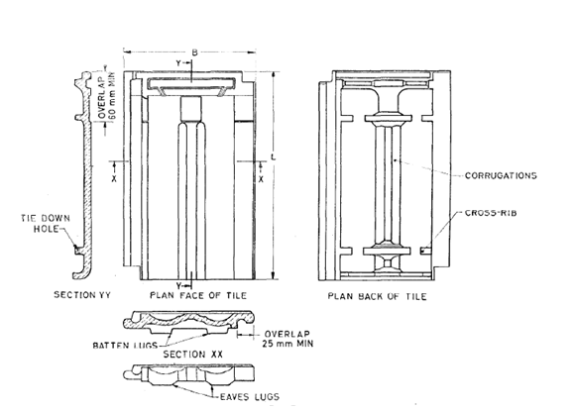

Figure A.1 — Typical details of a Mangalore tile (dimensions in millimetres)
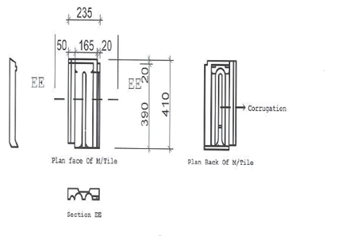
Figure A.2 — Typical details of Marseille tile (dimensions in millimetres)
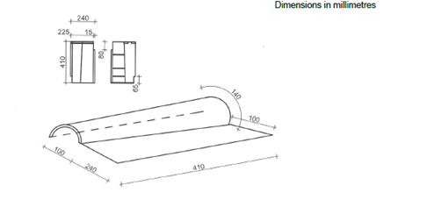
Figure A.3 — Typical details of Portuguese tile (dimensions in millimetres)
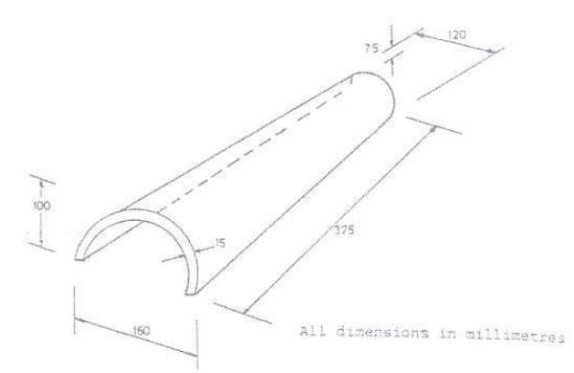
Figure A.4 — Typical details of Roman tile (Dimensions in millimetres)
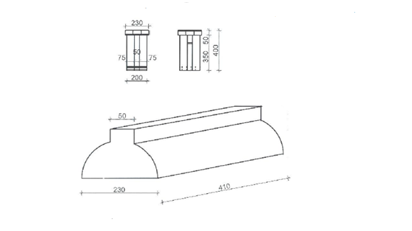
Figure A.5 — Typical details of ridge (dimensions in millimetres)
- (normative)
Permeability test
- Test specimen
Ten tiles shall be randomly selected to form the sample size according to the lot size as shown in Table 3 and used for this test.
Ten ridges shall be randomly selected to form the sample size according to the lot size as shown in Table 3 and used for this test.
- Apparatus
The test shall be conducted in a rectangular trough (see Figure 6) which is open at the bottom, the dimensions at the bottom being equal to the size of the tile.
- Procedure
B.3.1 The test shall be conducted at a temperature of 27 °C ± 2 °C and relative humidity of 65 % ± 5 %.
B.3.2 The tile (or ridge) shall be fitted at the bottom of the trough and the space between the tile and the sides of the trough plugged water-tight with suitable material like wax, bitumen, etc.
Water shall be poured into the mould so that it stands over the lowest tile surface to a height of 50 mm.
B.3.3 The water in the trough shall be allowed to stand for a period of six hours. The bottom of the tile shall then be carefully examined to see whether the water has seeped through the tile.

- (normative)
Determination of breaking load (for Mangalore and Marseille tiles)
- Test specimen
Ten tiles shall be randomly selected to form the sample size according to the lot size as shown in Table 3 and used for this test.
- Apparatus
A suitable form of apparatus is shown in Figure 7, consisting of two parallel self-aligning steel bearers, with the bearing surface rounded to 38 mm diameter, so placed that the distance between the centres could be altered. The load is applied through a third steel bearer of similar shape midway between and parallel to the supports. The length of all the bearers shall exceed the maximum width of the tile under test.
- Procedure
Test ten tiles in wet condition after soaking them in water at 20 ºC ± 2 ºC for 24 h. Support the tile centrally on the bearer set with a span of 25 cm and resting on the bottom surface. Apply the load with the direction of the load perpendicular to the span, at a uniform rate of 440 N/min to 540 N/min.
- Results
Report the average breaking load from the ten tests in N/mm width.

- (normative)
Determination of breaking load (for Roman and Portuguese tiles)
- Test specimen
Ten tiles randomly selected to form the sample size according to the lot size as shown in Table 3 shall be used for this test.
Ten ridges shall be randomly selected to form the sample size according to the lot size as shown in Table 3 and used for this test.
- Apparatus
This test may be conducted with any standard compression testing machine with provision for adjusting the rate of loading. A typical arrangement is shown in Figure 8.
- Procedure
Ten tiles or ridges in wet condition after soaking in water for 24 h shall be tested. The two longitudinal edges of the Roman or Portugal tile shall be kept, in normal position, over two strips of 25 mm thick rubber sheet placed on the table of the testing machine.
The load shall be applied to the tile or ridges by means of a wooden block of size 75 mm x 100 mm x 300 mm lined with rubber at the bottom, located symmetrically. The load shall be applied to the block at a uniform rate of 450 N/min – 600 N/min.
- Results
The individual breaking strength shall be obtained by dividing the breaking load by the width of the tile and the average of the value shall be calculated. The result shall be expressed in N/mm width.
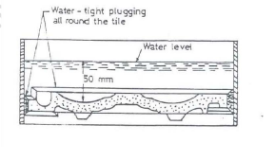
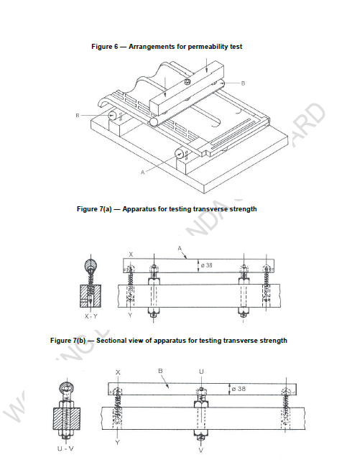
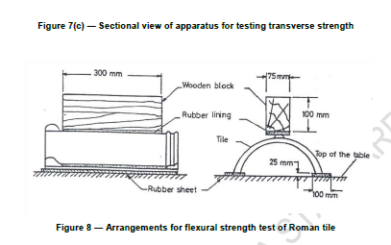
Bibliography
- KS 431-1: 2006, Clay roofing tiles — Specification

